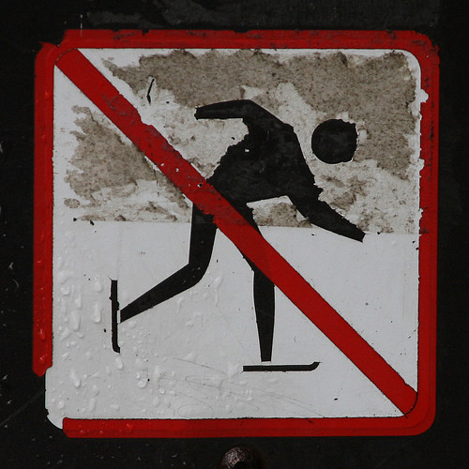

[This Photo](https://www.flickr.com/photos/128522571@N02/15934039859/) by Unknown Author is licensed under [CC BY-SA-NC](https://creativecommons.org/licenses/by-nc-sa/3.0/)